**ONLINE EXAMINATION SYSTEM**

**BCA Semester VI : PROJECT REPORT**

SUBMITTED IN FULFILLMENT OF THE REQUIREMENTS FOR THE AWARD OF

THE DEGREE OF

**BACHALOR OF COMPUTER APPLICATIONS**

(Bholabhai Patel College of Computer Studies,Gandhinagar)

**SUBMITTED TO**



**KADI SARVA VISHWAVIDYALAYA**

**SUBMITTED BY**

**Group No: 90**

|  |  |  |
| --- | --- | --- |
| Name | Roll no | University No |
| Hingladiya Riddhiben H. | 16191031 | 223 |
| Kanani Niraleeben H. | 16191267 | 234 |
| Makwana Divyaben D. | 16191231 | 260 |
| Patel Bhumikaben R. | 16191071 | 314 |

**Internal Guide:** **External Guide:**

B. P. College of Computer Studies

A Constituent College of

KADI SARVA VISHWAVIDYALAYA

**CERTIFICATE FROM DIRECTOR**

This is to certify that the project documentation entitled ‘**ONLINE EXAMINATION SYSTEM’** is bonafide project work done by **‘HINGLADIYA RIDDHI, KANANI NIRALI, MAKWANA DIVYA, PATEL BHUMIKA’** in fulfillment of the requirement for the award of degree of Bachelor of Computer Application at ***Bholabhai Patel College of Computer Studies, Gandhinagar*** – A Constituent College of ***KADI SARVA VISHWAVIDYALAYA.***

I further certify that the project work done by them is original work carried out at the campus under the supervision of the project guide.

Date: - __/__/____ _______

(Director)

B. P. College of Computer Studies

A Constituent College of

KADI SARVA VISHWAVIDYALAYA

**CERTIFICATE FROM INTERNAL GUIDE**

This is to certify that the project report compiled by **‘MISS** **HINGLADIYA RIDDHI,KANANI NIRALI,MAKWANA DIVYA, PATEL BHUMIKA’** students of semester-V/VI from BCA Department, ***Bholabhai Patel College of Computer Studies*** – A Constituent College of ***KADI SARVA VISHWAVIDYALAYA, Gandhiangar*** is done under our guidance. To the best of our knowledge, this work is satisfactory completed. During their tenure, they were found to be very hard working and sincere. They have completed all the tasks assigned and suggested to them.

Comments:-

1. ______________
2. ______________
3. ______________

_____________ _____________

(Internal Guide) (External Guide)

**Declaration**

We by declare that the entitled **“ONLINE EXAMITATION SYSTEM” at BHOLABHAI PATEL COLLEGE OF COMPUTER STUDIES** isrecordof independent research work and it has been carried out by our group during the period of our sem-6, submitted to **BHOLABHAI PATEL COLLAGE OF COMPUTER STUDIES**under the guidance of **PROF.JIGNESH PATEL**lecturer in department of BCA at **BHOLABHAI PATEL COLLAGE OF COMPUTER STUDIES.**

The award of the degree of **BACHELOR OF COMPUTER APPLICATION** is our original work , has not been submitted to any other university for the award of any degree or diploma.

**Acknowledgment**

We would like to express my special gratitude to my internal guide who gave us the golden opportunity to do this wonderful project on the **ONLINE EXAMINATION SYSTEM** which also helped us in doing a lot of research and we come to know about so many new things.

Secondly I would also like thank all my group members for their wonderful cooperation to finishing this project within the particular tile line helped me in increase my knowledge and skills.

**Index**

**CONTENTS**

**1: Project Definition 4**

**2: Need of Project 5**

**3: Scope and Limitations 7**

**4: Existing System Advantage & Disadvantage 8**

**5: Proposed System 9**

**5.1: Advantages 10**

**6: Feasibility Study 10**

**6.1: Operational Study 11**

**6.2: Technical Study 11**

**6.3: Economical Study 12**

**6.4: Schedule Study 13**

**7: System Requirement Specification 17**

**8: Data Flow diagram 20**

**8.1: Context Level 21**

**8.2: First Level 22**

**8.3: Second Level 23**

**8.4: Third Level 24**

**9: ERD 21**

**10: Data Dictionary 22**

**11: Screen Shots 30**

**12: Reference 53**

**13: Conclusion 53**

* **INTRODUCTION**
* Online Exams is being launched because a need for a destination

that is beneficial for both institutes and students.

* Students can give exams and view their results. This site is an attempt to remove the existing flaws in the manual system of conducting exams.

1. **Project Definition:**

* Online examination is a good approach to standardize the examination method.
* Online examinations as a technology through which the multiple users can interact with examination system on computer face the exam with each random or same

Question.

* **Technology & Platform:**

**Technology:**

PHP 5.2.9

**Front-End:**

HTML,CSS

**Back-End:**

Mysql 5.1.31

**Platform:**

Wamp server 2.0

* **Purpose:**
* Online Exams System fulfills the requirements of the institutes to conduct the exams online.
* They do not have to go to any software developer to make a separate site for being able to conduct exams online.
* They just have to register on the site and enter the exam details and the lists of the students which can appear in the exam.
* Students can give exam of going to any physical destination. They can view the result at the same time.
* Thus the purpose of the site is to provide a system that saves the efforts and time of both the institutes and the students.

**2. Need of Project:**

There are three major components of efforts required to administer an examination:-

I. Create the examination, and keep the contents secure until the examination starts.

II. Supervise the examination

III. Mark the examinations.

  Using computer technology, it should be possible to streamline these three phases, and also disconnect them from each other.

  Examination system offers the following features:-

I. Reliability

II.User details

* **Organization Details:**
* **Organization Name:** Smt. R. C. Patel Seconadary School.
* **E-Mail:** [rcpatelschoolgnr@gmail.com](mailto:rcpatelschoolgnr@gmail.com).
* **Address:** Sector-23, Near GH-6 , Kadi Campus, Gandhinagar.
* **City:** Gandhinagar
* **State:**Gujarat
* **About Us:**
  + **Name:** Smt R.C.Patel Secondary school
  + **Contact Number:**097233 34050
  + **Directer name:** Mr.Vinod patel

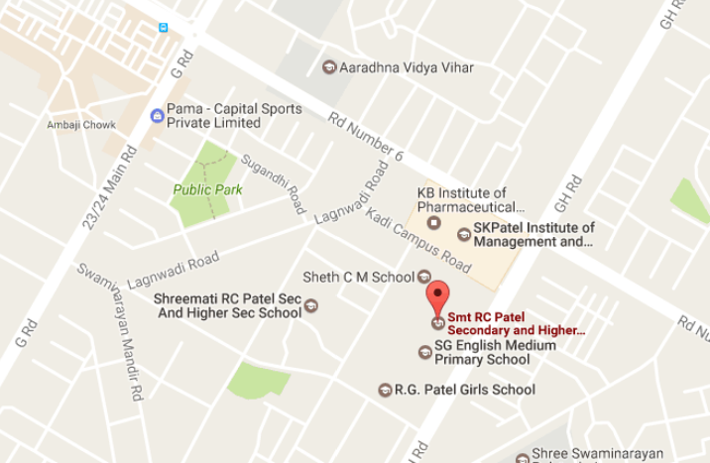

**3. Scope& Limitations:**

**Scope:**

* This project would be very useful for educational institutes where regular evaluation of students’ is required. Further it can also be useful for anyone who requires feedback based on objectives type responses.

**Limitations:**

* + Current system provides only multiple choices but single correct answer selection.
  + Incase questions or answers need to be in graphics, current system has no provision.
  + Unregistered users can only access the home page not anything else like type of exam.
  + Student only can see her results. Top score is not displayed.

**4. EXISTING SYSTEM STUDY:**

* + **Existing System:**

The first problem is that there are loads of hard copied documents being generated. This brings us to the age-old discussion of keeping information in the form databases versus keeping the same on sheets of paper. Keeping the information in the form of hard-copied documents leads to the following problems:

* **Lack of space:** It becomes a problem in itself to find space to keep the sheets of paper being generated as a result of the ongoing discussion. The documents being generated are too important to be ill-treated.
* **Filtering is not easy:** It becomes hard to filter relevant documents for the irrelevant ones if the count of the same crosses a certain Manageable number.
* **Reviewing becomes time-consuming :**All the process done manually at the centers and all the records are maintained on the papers. So the maintenance of the record is very difficult in the departments and as well as it’s very difficult for the workers to check the record. The Existing system is paper based, time consuming, monotonous, less flexible and provides a very hectic working schedule.
* **Question paper :** Concern faculty sets Question-paper and it has to be printed separately for each student.
* **Answering:** Each student is given a separate answer sheet in which they write their answers descriptively.
* **Evolution:** Examiner has to read each paper, and he gives marks according to the answers given by students.
* **Results:** Marks of the exam are entered manually into the computer system or other system and from that result is displayed.

Result Processing is slow due to paper work and requirement of staff.

* + **Disadvantages:**

The following drawbacks of existing system emphasize the need for computerization:

* A lot of copies of question papers have to be made
* A lot of correction work hence delay in giving the results
* A lot of tabulation work for each subject results
* Time consuming
* Expensive
* Conducting Exam
* Semi-Manual

**5. Proposed System :**

The application is used to conduct online examination. The students can sit at individual terminals and login to write the exam in the given duration. . The questions have to be given to the students. This application will perform correction, display the result immediately and also store it in database. This application provides the administrator with a facility to add new exams. This application provides the Instructor add questions to the exam, modify questions in the exam in a particular exam. This application takes care of authentication of the administrator, Instructor as well as the student.

* Computerized examination system
* Multi-user
* Objective type test
* Data resides on server
* Evaluation done immediately by system itself
* Quick result report

**5.1Advantages:**

* Computerized system
* Fast Evaluation & Result processes
* Fast Analysis
* Student check his knowledge
* Randomly Questions and Same Questions
* Quick Result

**6. Feasibility Study:**

Feasibility study is conducted once the problem is clearly understood. Feasibility study is a high level capsule version of the entire system analysis and design process.

The objective is to determine quickly at a minimum expense how to solve a problem. The purpose of feasibility is not to solve the problem but to determine if the problem is worth solving.

The system has been tested for feasibility in the following points.

1. Operational Feasibility

2. Technical Feasibility

3. Economic Feasibility

4. Schedule Feasibility

***1.Operational Feasibility:***

* In the project, the management will know the details of each project where he may be presented and the data will be maintained as decentralized and if any inquires for that particular contract can be known as per their requirements and necessaries.
* The system was well supported by the management with the principal taking personal interest in the system development process.
* The proposed system makes a best effort to satisfy the requirements of all the principal, Faculties, school’s Students and Visitors Keeping in mind certain infrastructure constraints.

***2. Technical Feasibility:***

* It provides the high level of reliability, availability and compatibility. All these make PHP an appropriate language for this project.
* Departments with the requisite technology to cater to the needs of the proposed system. Any additional requirements can also be satisfied

***3. Economic Feasibility:***

* The computerized system will help in automate the selection leading the profits and details of the organization. The costs incurred of not creating the system are set to be great, because precious time can be wanted by manually.
* The cost of conducting a full systems investigation is justified since the development is in-house.
* All these factors overall effects the performance in a positively way.

***4. Schedule Feasibility:***

It will include the following Levels:-

* **Scope of Project:**

It will include Project Scope.

* **Planning:**

It will include Planning of the project

* **Analysis:**

In this Analysis will be Done on Student's data or Information

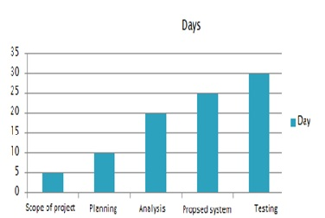

* **Proposed System:**

It will Include Our Future System.

* **Implementation:**

It will Include Implementation of Project what things will be implement in our Project.

* **System Design:**

It will include Designing Part of the Project.

* **User Training:**

User will be given Training According to the Project.

* **Modules:**

**I.*Admin Module:***

1. Register

2. Login

3. Change password and Forget password

4. Student-Modifying Details

5. Departments-Entering/Modifying Details

6. Instructor details-Modifying details

**1.Register:** To be authenticated first have to be registered.

**2. Login:** The registered user can be allowed to view inner details for which he permitted.

**3. Charge password &Forgot password:** User has rights to modify his login details & also be informed through mails if he is unable to login.

**4. Student-Modifying Details:** User can be modified to change status of each user.

**5. Departments-Entering/Modifying Details:** New department adding and old department deletion are spend by this user.

**6. Instructor Details-Modifying Details:** According to staff he can add or delete instructors for specific platforms.

***II. Student Details:***

1. Register

2. Login

3. Take Exam-Multiple choice

True/False

4. See exam results

5. Log out

**1. Register**: To be authenticated first have to be registered

**2. Login:** The registered user can be allowed to view inner details for which he permitted.

**3. Take exam:** Multiple choice,

True/False: The registered student allowed to start the exam

**4. See exam results:** After completion of exam he can view at his results

**5. Log out:** After the process of examination he turned to logout page.

**7. System Requirement Specifications:**

* **Client Side:**

***Software Specification:***

* Browser: internet Explorer 5.0 or Compatible web browser.

**Hardware Specification:**

* RAM: 1.0 GB
* HardDisk :10.0 GB
* Processor:2.5 GHz
* **Server side:**

***Software Specification:***

* *Os:WindowXp*
* *Server :IIS 5.0 or Above*
* Browser: internet Explorer 5.0 or Compatible web browser.
* Database : MYSQL

**Hardware Specification:**

* RAM: 1.0 GB
* HardDisk :40.0 GB
* Processor:2.5 GHz
* **Developer Side:**

***Software* Specification:**

* Operating System : Windows
* Web-Technology: PHP
* Front-End: HTML,CSS
* Back-End: MySQL
* Web Server: Apache SERVER.

***Hardware* Specification:**

* Intel(R) Core(TM) i3-4005U CPU @ 1.70GHz (Processor).
* 256 MB Ram
* 305 KB Cache Memory
* Hard disk 10 GB
* Microsoft Compatible 101 or more Key Board

**8. Data Flow Diagram:**

**8. Data Flow Diagram:**

* The DFD takes an input-process-output view of a system i.e. data objects flow into the software, are transformed by processing elements, and resultant data objects flow out of the software.
* A context-level DFD for the system the primary external entities produce information for use by the system and consume information generated by the system. The labeled arrow represents data objects or object hierarchy.
* here are three types of data flow diagram:
* **8.1**  Context level
* **8.2**1st level
* **8.3** 2nd level
* **8.4** 3rd level

**8.1 Context level :**

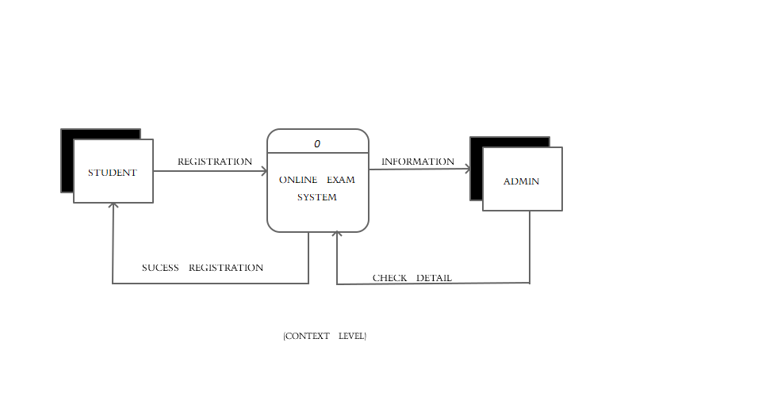

**8.2 1st level:**

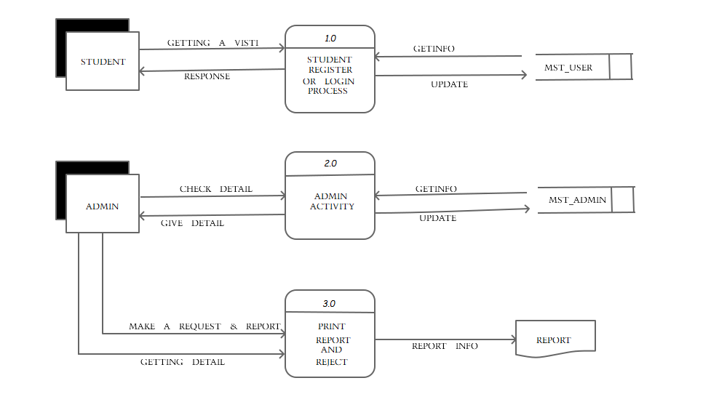

**8.3 2nd level:**

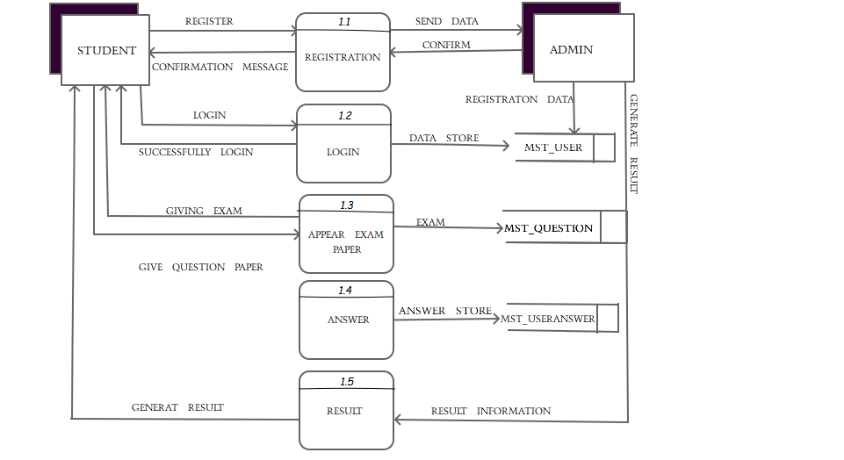

**8.3 3rd level:**

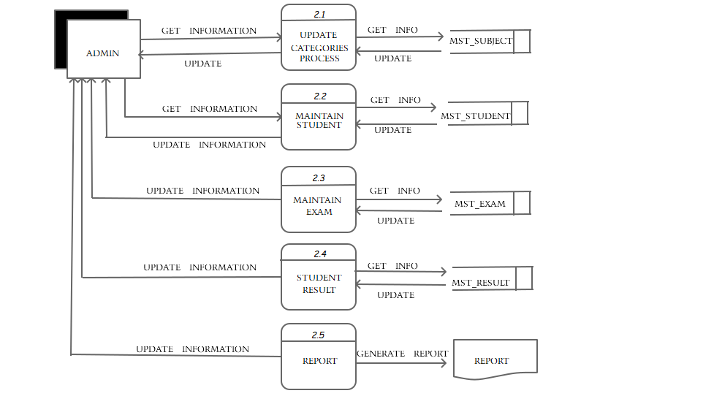

**9.ER Diagram:**

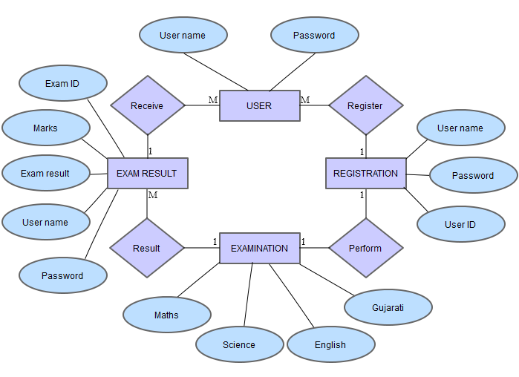

**10. Data Dictionary:**

1. **Admin:**

|  |  |  |  |  |
| --- | --- | --- | --- | --- |
| **Name** | **Type** | **Key** | **Validation** | **Description** |
| Username | VARCHAR(20) | NOT NULL | - | Username |
| Password | VARCHAR(8) | NOT NULL | Only 8 digit | Password |

**2. Student Register Table:**

|  |  |  |  |  |
| --- | --- | --- | --- | --- |
| **Name** | **Type** | **Key** | **Validation** | **Description** |
| ID | INT(3) | PK | - | Student Id |
| Password | VARCHAR(8) | NOT NULL | Only 8 digit | Password |
| Name | VARCHAR (10) | NOT NULL | Only alphabet | Student Name |
| Address | VARCHAR(60) | NOT NULL | - | Student Address |
| Gender | VARCHAR (6) | NOT NULL | - | Student Gender |
| City | VARCHAR(10) | NOT NULL | Only alphabet | Student city |
| Email | VARCHAR(20) | NOT NULL | Starting not @ | Student Email |
| Phone no. | NUMBER(10) | NOT NULL | Only ten digit | Student Phone no. |

**3. Question Bank:**

|  |  |  |  |
| --- | --- | --- | --- |
| **Name** | **Type** | **Key** | **Description** |
| Q_Id | INT(3) | PK | Question id |
| Q_name | VARCHAR(500) | NOT NULL | Question name |
| Answer1 | VARCHAR(100) | NOT NULL | Answer1 |
| Answer2 | VARCHAR(100) | NOT NULL | Answer2 |
| Answer3 | VARCHAR(100) | NOT NULL | Answer3 |
| Answer4 | VARCHAR(100) | NOT NULL | Answer4 |
| True Answer | INT(1) | NOT NULL | True Answer |

**4. Result:**

|  |  |  |  |
| --- | --- | --- | --- |
| **Name** | **Type** | **Key** | **Descirption** |
| S_ID | INT(3) | FK | Student id |
| Exam_Date | DATETIME | NOT NULL | Date of exam |
| Total Question | INT(3) | NOT NULL | Total question |
| Marks | INT(3) | NOT NULL | Total marks |

**5. Useranswer:**

|  |  |  |  |
| --- | --- | --- | --- |
| **Name** | **Type** | **Key** | **Descirption** |
| Test_id | INT(11) | PK | Test id |
| Que_Des | VARCHAR(200) | NOT NULL | Quationdesctription |
| Ans1 | VARCHAR(50) | NOT NULL | Answer 1 |
| Ans2 | VARCHAR(50) | NOT NULL | Answer2 |
| Ans3 | VARCHAR(50) | NOT NULL | Answer3 |
| Ans4 | VARCHAR(50) | NOT NULL | Answer4 |
| True_Ans | INT(11) | NOT NULL | True answer |
| Your_Ans | INT(11) | NOT NULL | Student answer |

**6. UserTest:**

|  |  |  |  |
| --- | --- | --- | --- |
| **Name** | **Type** | **Key** | **Descirption** |
| Test_id | INT(5) | PK | Test id |
| Sub_id | INT(5) | NOT NULL | Subject id |
| Test_name | VARACHR(30) | NOT NULL | Test name |
| Total_que | VARCHAR(15) | NOT NULL | Total question |

**7. SubjectName:**

|  |  |  |  |
| --- | --- | --- | --- |
| **Name** | **Type** | **Key** | **Description** |
| Subject_id | INT(5) | PK | Subject id |
| Subject_name | VARCHAR(25) | NOT NULL | Subject name |

**11. Screen Shot:**

**1. Student Registration:**

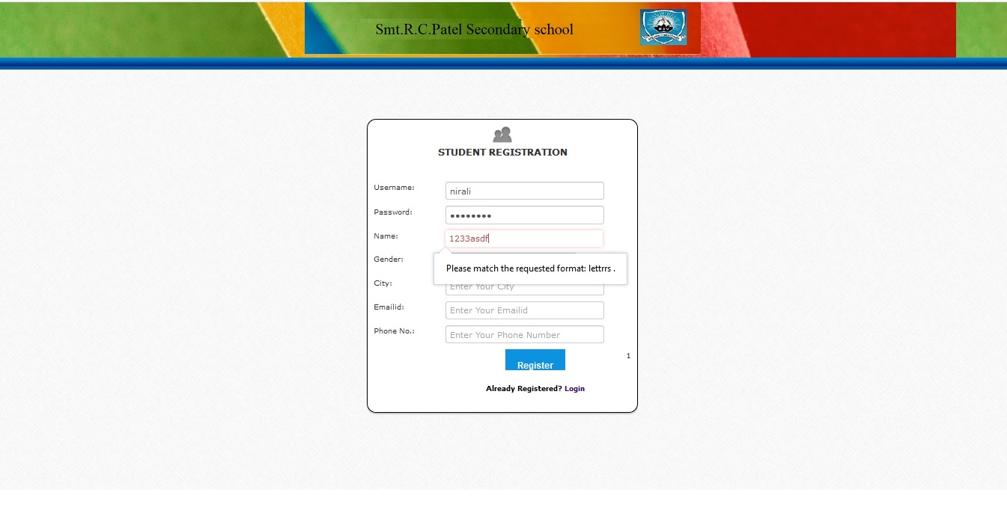

* **Password Validation:**

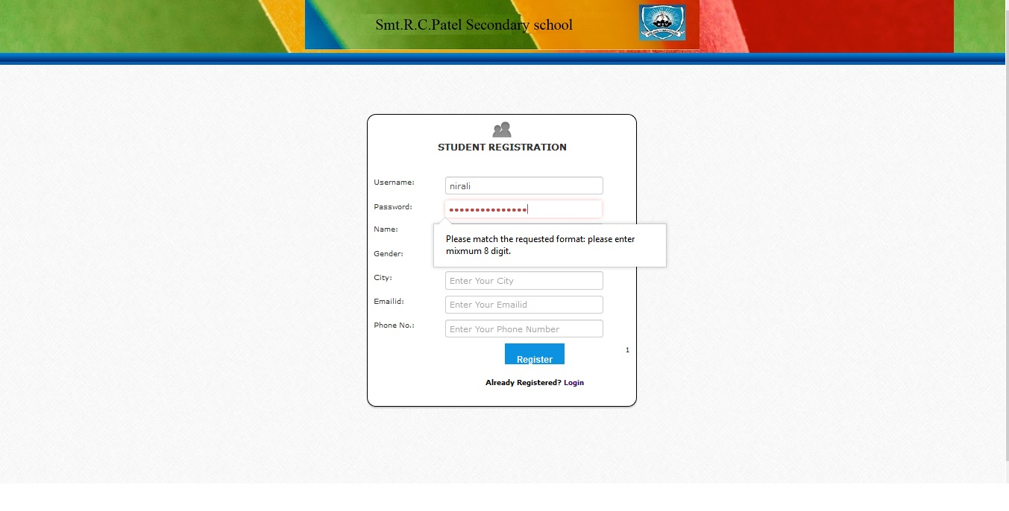

* **Email Validation:**

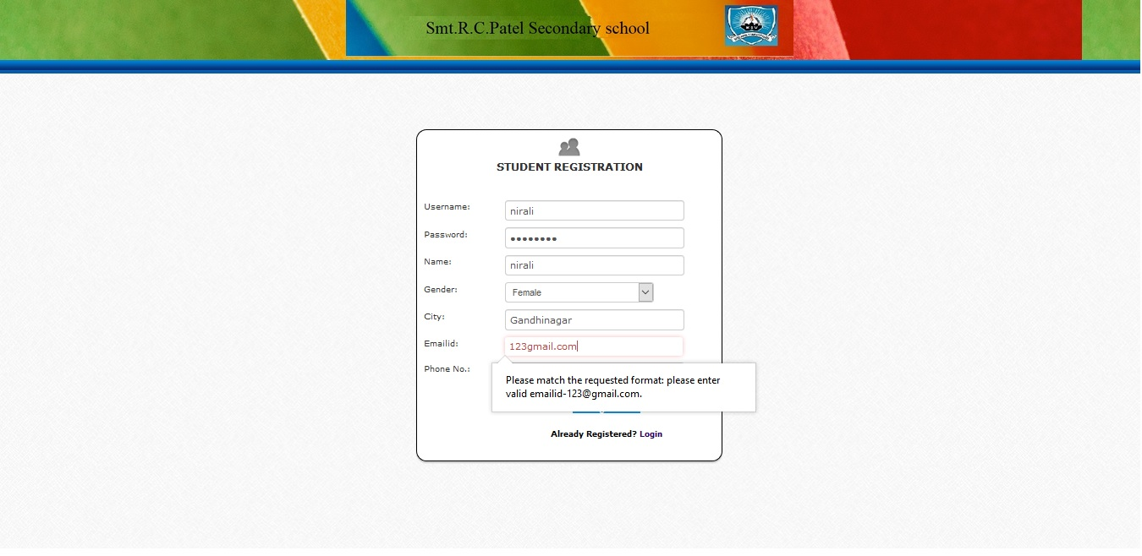

* **Phone number validation:**

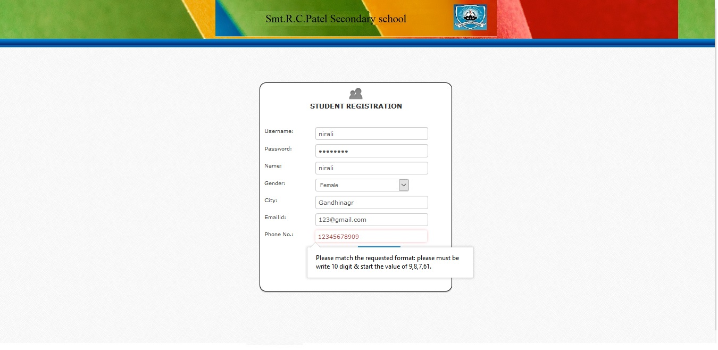

* **Successfully Signup:**

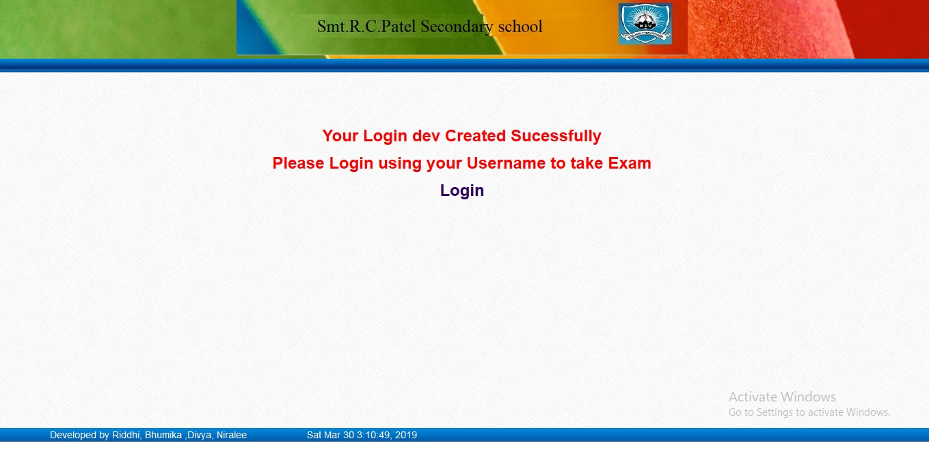

1. **Chanage password:**

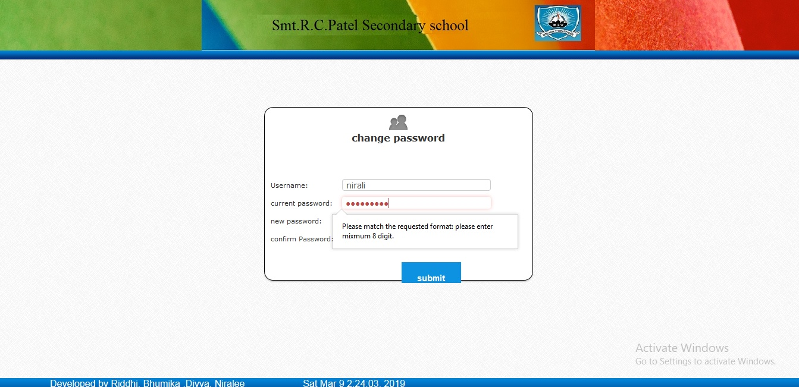

* **Password Not Match:**

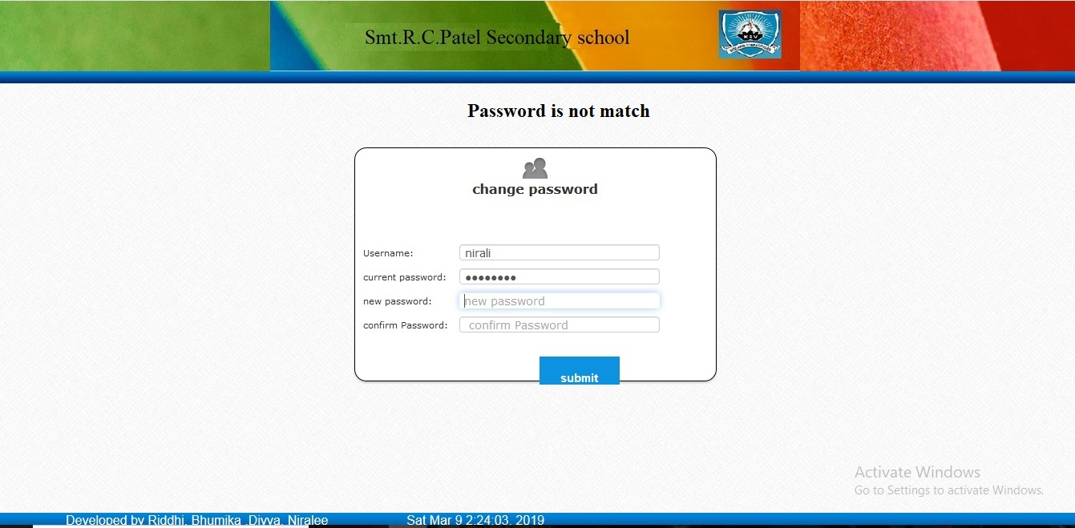

1. **Student Login:**

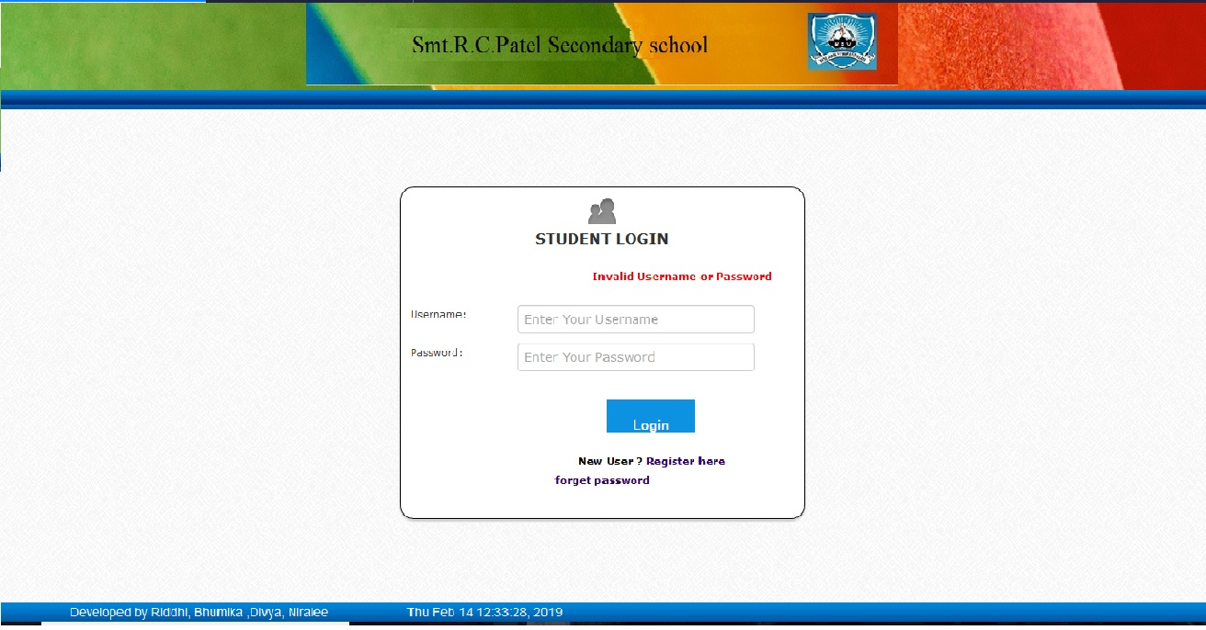

* **Exam Area Student:**

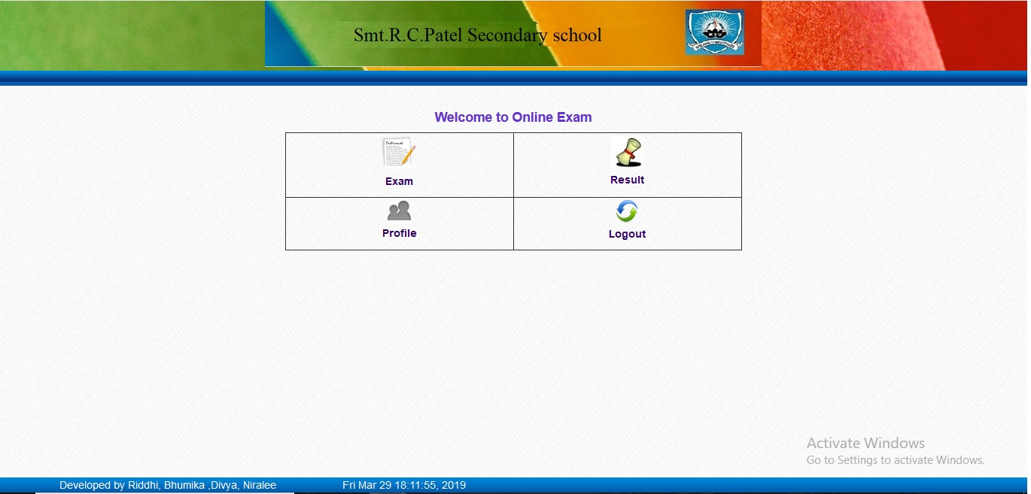

* **Subject for Student Exam:**

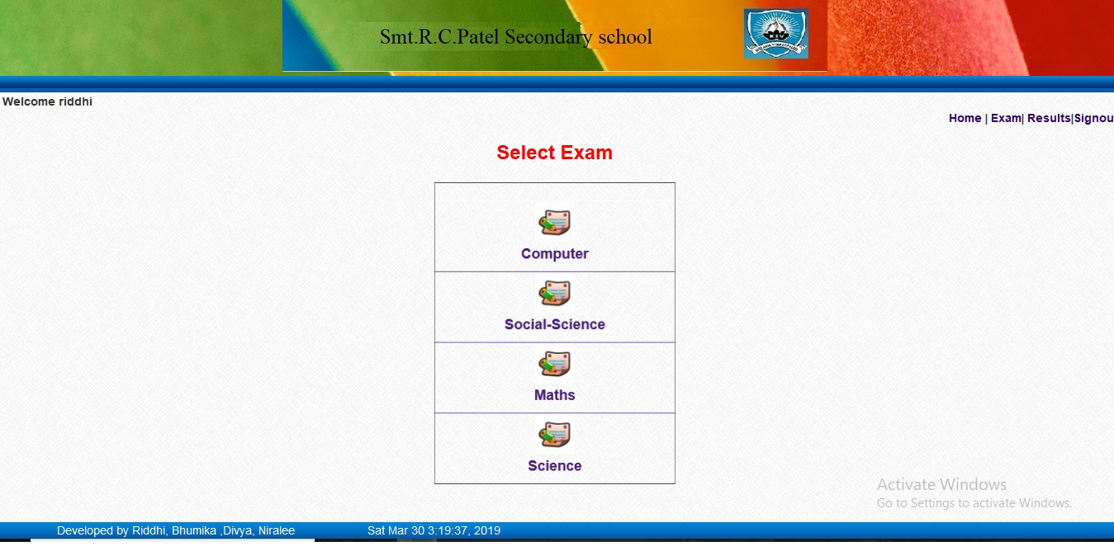

* **Take To Exam:**

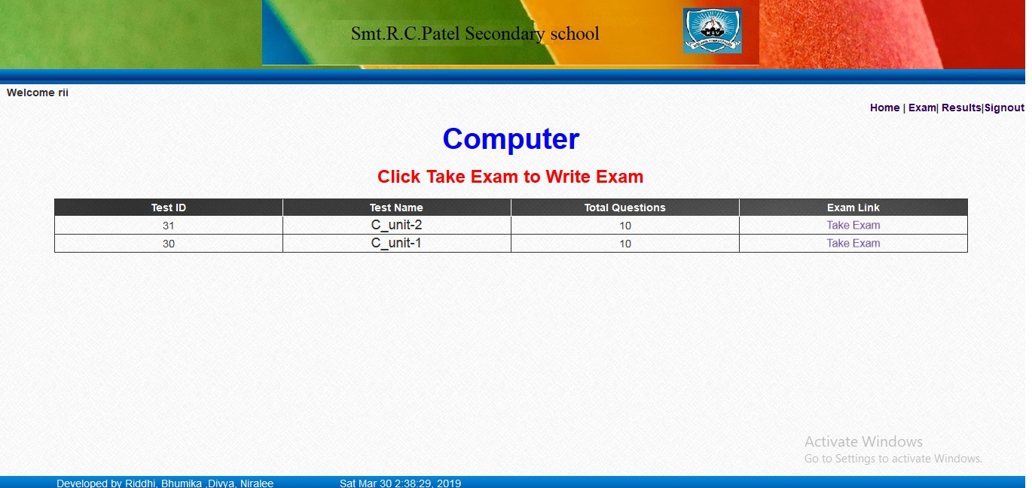

* **Random Question Answer:**

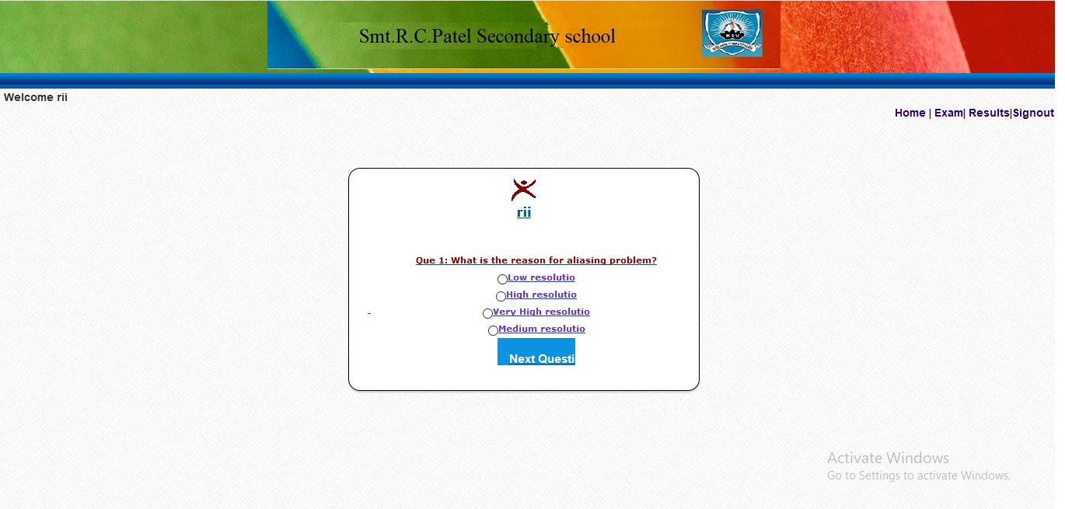

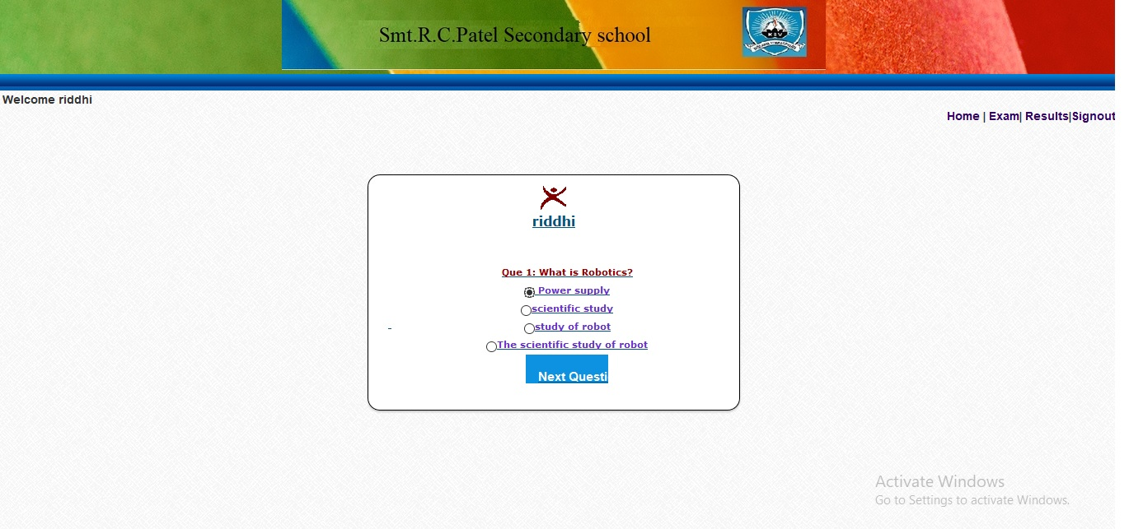

* **Review Question:**

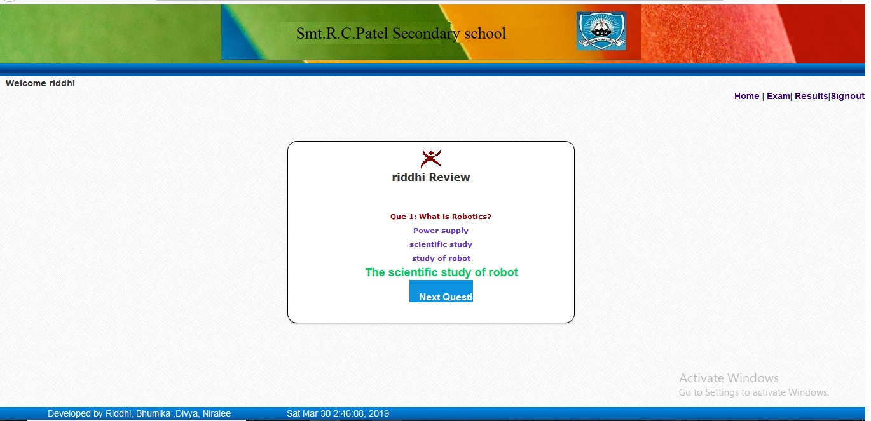

* **Result For Student:**

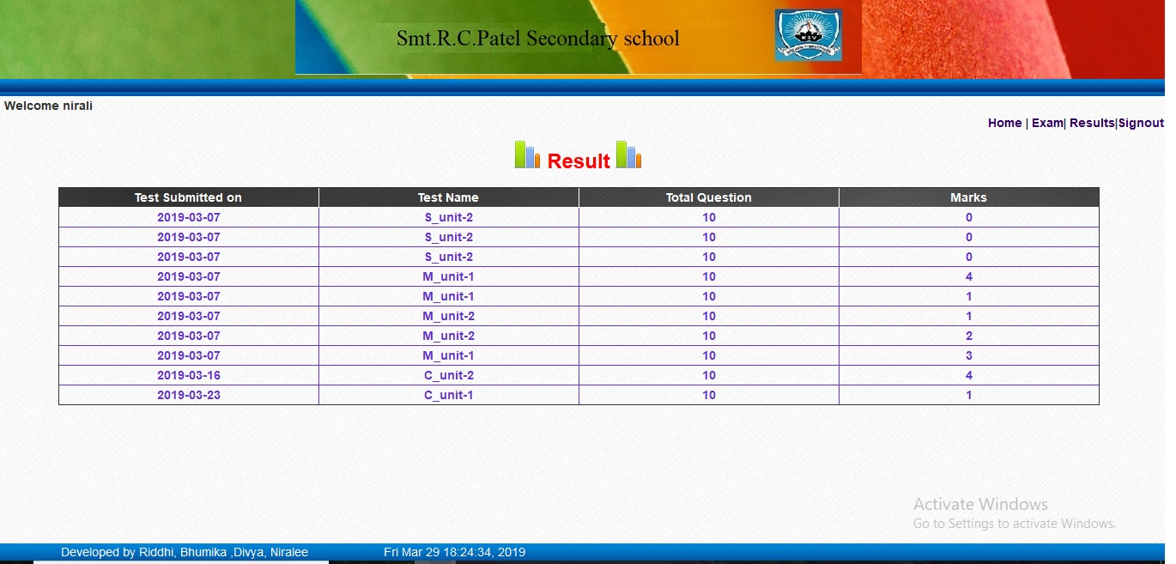

* **Profile For Organization:**

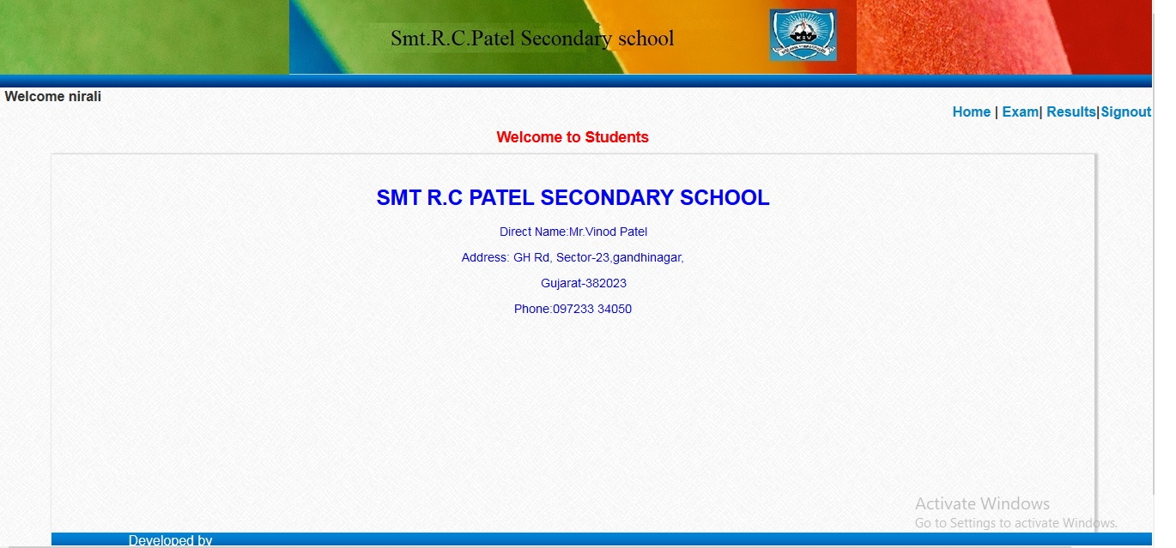

1. **Admin Login:**

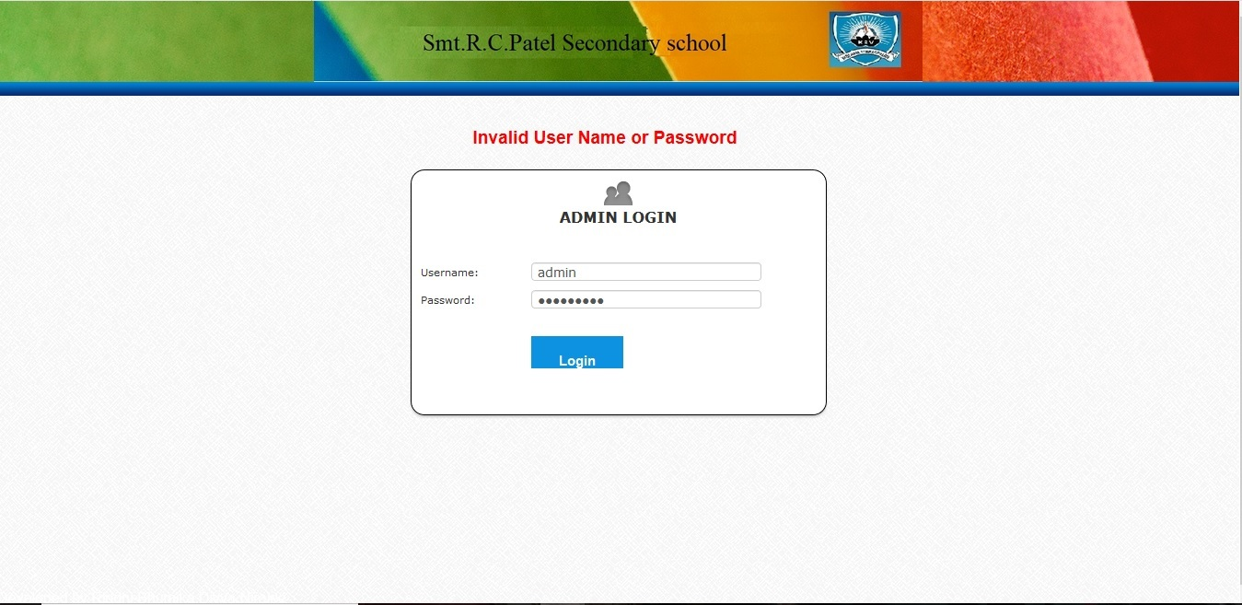

* **Admin Area:**

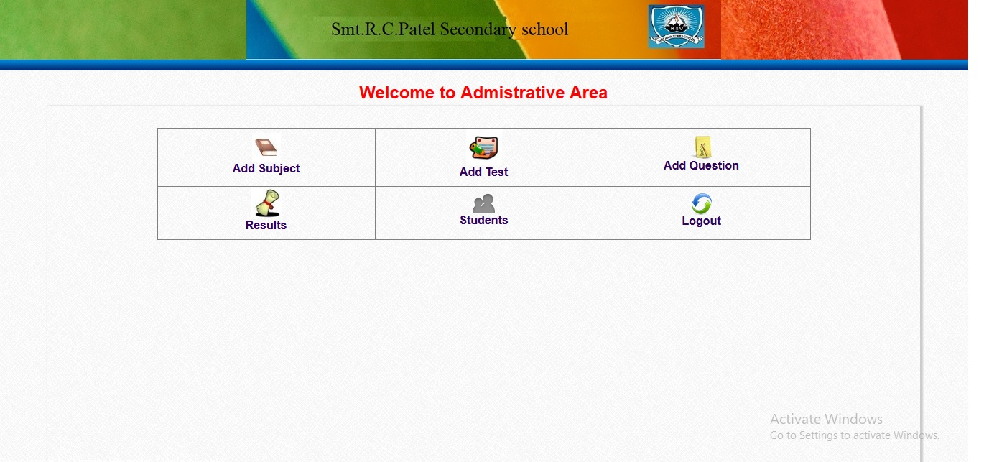

* **Add subject:**

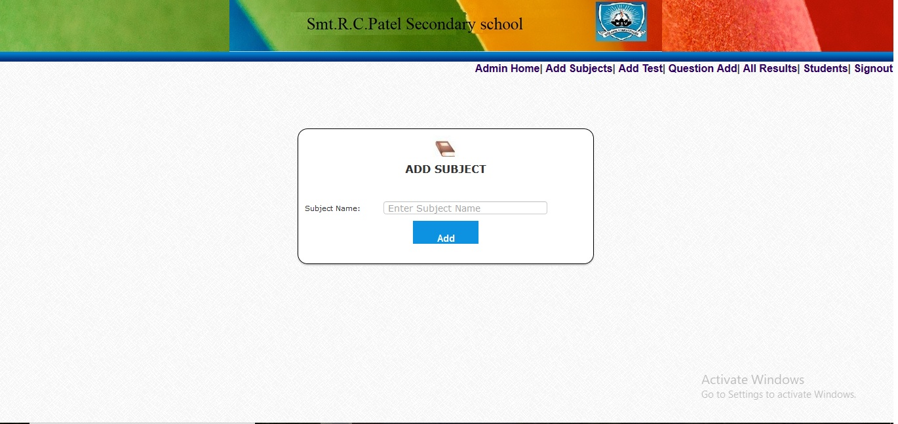

* **Add Test:**

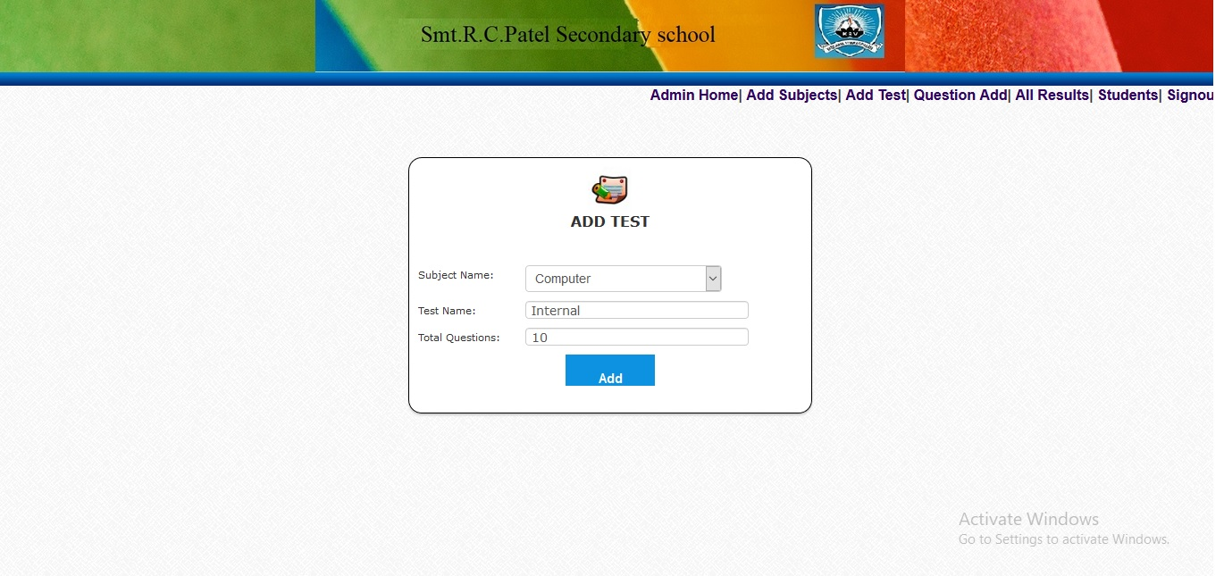

* **Add Question:**

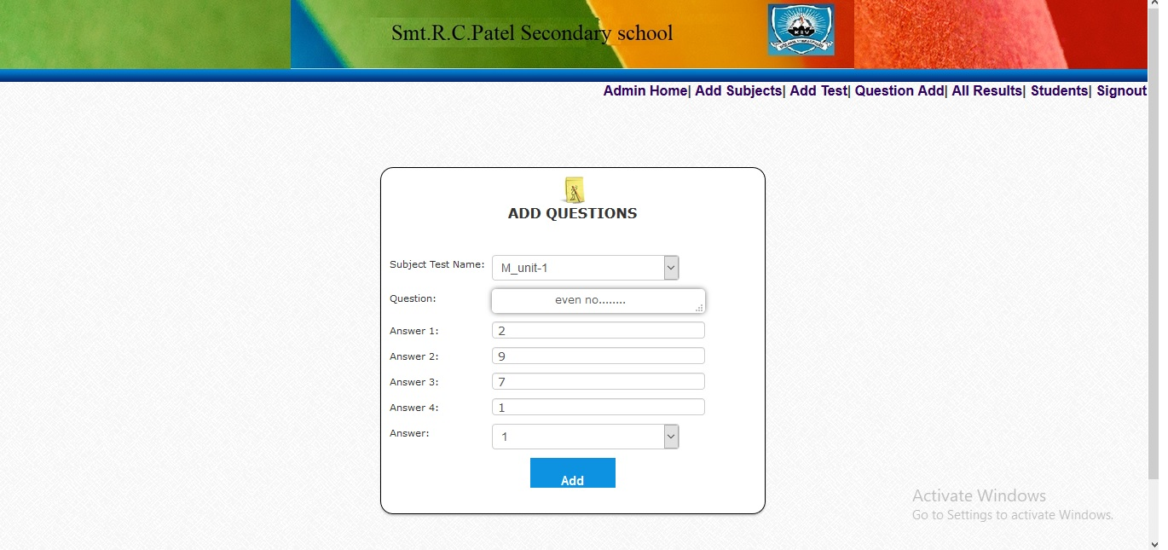

* **All Result:**

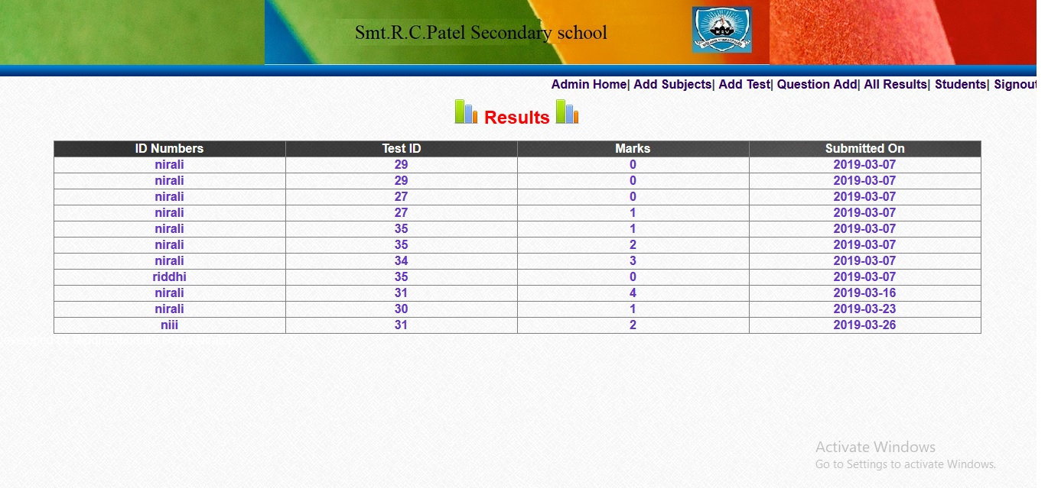

* **Student Information:**

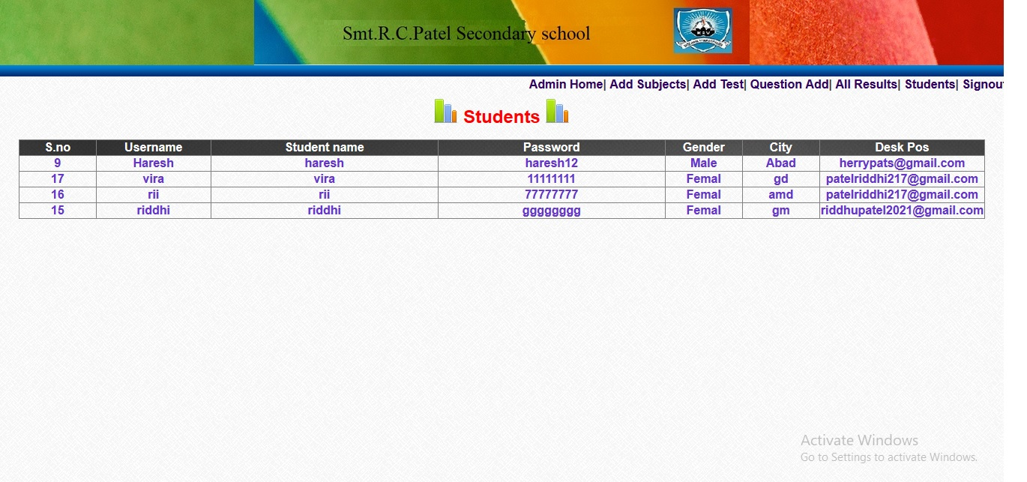

**12. Reference:**

**Book Name:** Murch’s PHP and MYSQL

**Author Name:** JoleMurach& Ray Harris

2nd Edition

**13. CONCLUSIONS**

This Web Application provides facility to conduct online examination. It saves time as it allows number of students to give the exam at a time and displays the results as the test gets over, so no need to wait for the result.

Administrator has a privilege to create, modify and delete the exam and its particular questions. User can register, login and give the test with his specific id, and can see the results as well.